March 20, 2022

Bible Exploration 10:00
Worship service 10:50 am

Prelude

Worship in Song
Amanda & Ron

Welcome & Announcements
Darrel

Scripture Reading & Prayer
Melvyn

Offering

Worship in Song
Amanda & Ron

Children’s Church
Kathy

Message
Pastor Ron

Postlude

Happy Birthday
Hylke van der Wal

Praise & Prayer

- Pray for Sara’s healing as she is experiencing extreme pain a slow recovery from a broken ankle
- Pray for peace in Ukraine
- Pray - for Gerry and Heather as they are with his ailing mother in BC
- Pray for Sue as she recovers from cataract eye surgery this week
- Praise the Lord for Mary’s swift recovery

Weekly Praying for:
Global – Paul & Jan
Borden – Brian & Sylvia Mitchell

MCC Connects (MCC) will be responding to the crises in Ukraine through its local partners. Your prayers and donations will help partners scale up their work providing relief and trauma healing for vulnerable and displaced people.
“Ukraine is experiencing major upheaval, but our partners have supplies ready to help,” says Rebecca Hessenaur, MCC representative for Ukraine.
Donate at mcccanada.ca/ukraine

Redberry Bible Camp Corner

1. Please pray that we will be
able to run overnight camps
and pray for summer staff.
2. Camp needs hay -please contact us-306-477-4410.
3. March 17-20, Ladies Craft Retreat
See website for details to register

Places to help others
Jackets
Sweaters
Hygiene Items
Men's & Women's Pants

Service Leader
Mar 20 - Darrel
Mar 27 - Ron
Apr 3 - Gary
Apr 10 - Kelly
Apr 17 - Sue

Scripture & Prayer
Mar 20 - Melvyn
Mar 27 - Charles
Apr 3 - Carson
Apr 10 - Diane
Apr 17 - Andrew

Worship Leaders
Mar 20 - Amanda & Ron
Mar 27 - Peter, Mary & Ron
Apr 3 - Darrel & Kathy & Ron
Apr 10 - Amanda & Ron
Apr 17 - Peter, Mary & Ron

Care Home Shuttle Service
Mar 20 - Charles
Mar 27 - Ron
Apr 3 - Stew
Apr 10 - Rueben
Apr 17 - Gerry

Please contact Ron if you want to help.

Children’s Church
Mar 20 - Kathy
Mar 27 - Heather
Apr 3 - Darrel
Apr 10 - Kathy
Apr 17 - Sue

Please Contact Ron or Kathy
for bulletin announcements

Notes
______________________________________________________________________________________________________________________________________________________________________________________________________________________________________________________________________________________________________________________________________________________________________________________________________________________________________________________________________________________________________________________________________________________________________________________________________________________________________________________________________________________________________________________________________________________________________________________________________________________________________
_______________________________
_______________________________
_______________________________

Riverbend
Fellowship (MB)

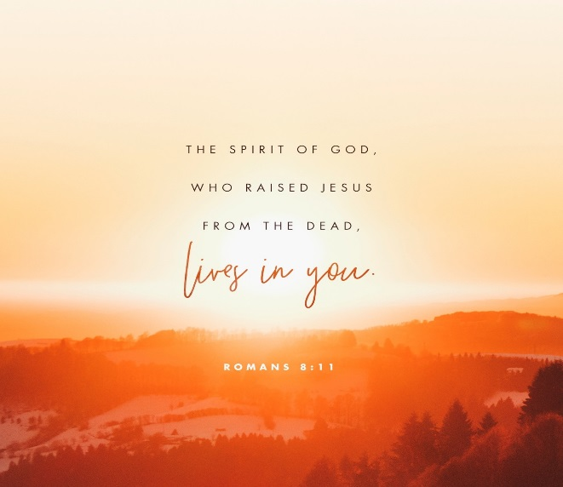

Seniors' Room
Borden Community Centre
riverbendfellowship.weebly.com
Box 256, Borden SK, S0K 0N0
riverbendfellowshipmb@gmail.com
Pastor - Ron Mills
306-997-0020
Bible exploration 10 am
Worship Service 10:50am

